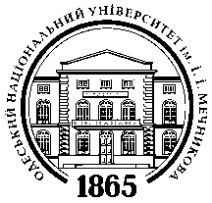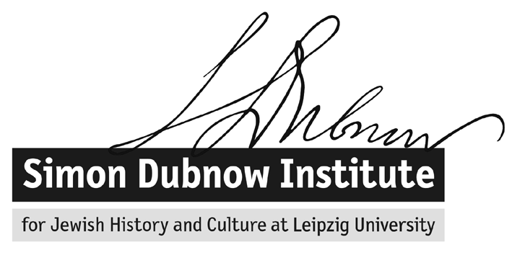

The International Forum of Young Scholars on East European Jewry
Odessa, 1-4 July 2013
I.I. Mechnikov Odessa National University, 2, Dvorianska St.
Meeting room on the first floor (one above the ground floor) inside Rector’s office
Schedule of Activities

July 1, Monday
8.00 – 9.00 Breakfast “Café Fason”, 28, Preobrazhenskaya St.
12:30 Lunch (Buffet of Odessa National University, 2, Dvorianska St., ground floor)
13:00 Orientation at ONU
13:30 – 14:30 Greetings and technical clarifications.
14:30 – 15:00 Discussion: Goals and objectives of the Forum and brief introductions by Forum participants.
15:00 – 16:00 Discussion: “Why Odessa?” Jewish and non-Jewish Heritages and Mythologies.
16:00 – 16:30 Coffee break (Buffet of Odessa National University).
16:30 - 18:00 Research presentations by young scholars (Group A).
18:30 Dinner: «Café Laffka», 24, Lanzheronovskaya St.
20:00 Optional Evening Activity: “Footnote” - film viewing & following discussion (Israeli Culture Center, 17, Grecheskaya St., 4th floor).

July 2, Tuesday
8.00 – 9.00 Breakfast “Café Fason”, 28, Preobrazhenskaya St.
09:30 – 11:00 Research presentations by young scholars (Group B).
11:00 – 11:30 Coffee break (Buffet of Odessa National University).
11:30 – 13:00 Workshop: The Borders between Literature Studies and Historiography.
13:00 – 14:00 Lunch (Buffet of Odessa National University).
14:00 – 15:30 Workshop: Presenting Effectively at Academic Conferences.
15:30 – 16:00 Coffee break (Buffet of Odessa National University).
16:00 – 19:30 Tour: “Jewish and Non – Jewish Odessa”, part 1.
20:00 Dinner «Café Laffka», 24, Lanzheronovskaya St.

July 3, Wednesday
8.00 – 9.00 Breakfast Café Fason, 28, Preobrazhenskaya St.
09:30 – 11:00 Research presentations by young scholars (Group C).
11:00 – 11:30 Coffee break (Buffet of Odessa National University).
11:30 – 13:00 Workshop: Teaching Skills.
13:00 – 14:00 Lunch (Buffet of Odessa National University).
14:00 – 15:30 Workshop: Getting Grants, Seeking Employment and Preparing for Job Talks.
15:30 – 16:00 Coffee break (Buffet of Odessa National University).
16:00 – 19:30 Tour: “Jewish and Non-Jewish Odessa”, part 2.
20:00 Dinner «Café Laffka», 24, Lanzheronovskaya St.

July 4, Thursday
8.00 – 9.00 Breakfast “Café Fason”, 28, Preobrazhenskaya St.
09:30 – 11:00 Research presentations by young scholars (Group D).
11:00 – 11:30 Coffee break (Buffet of Odessa National University).
11:30 - 13:00 Workshop: Publication Strategy – When, What and Why?
13:00- 14:00 Lunch (Buffet of Odessa National University).
14:00 - 16:00 Consultations with senior scholars (in small groups):
Israel Bartal
Jonathan Dekel – Chen
David Engel
Zvi Gitelman
Gabriella Safran
16:00 – 16:30 Coffee break (Buffet of Odessa National University).
16:30 -17:30 Closing session (feedback, remarks, looking forward, etc.).
18:00 Dinner «Café Laffka», 24, Lanzheronovskaya St.

Accommodation: “Deribas”, 27, Deribasovskaya St., tel.048-7000521, www.hotel-deribas.com

Forum’s coordinator: Kristina Petrishina + 38 (050) 0656466
Semion Goldin’s local cell phone number (starting from June, 30): +38(066) 0418615

